**Tearsheet Writer’s Template (Service Offering and Solutions)**

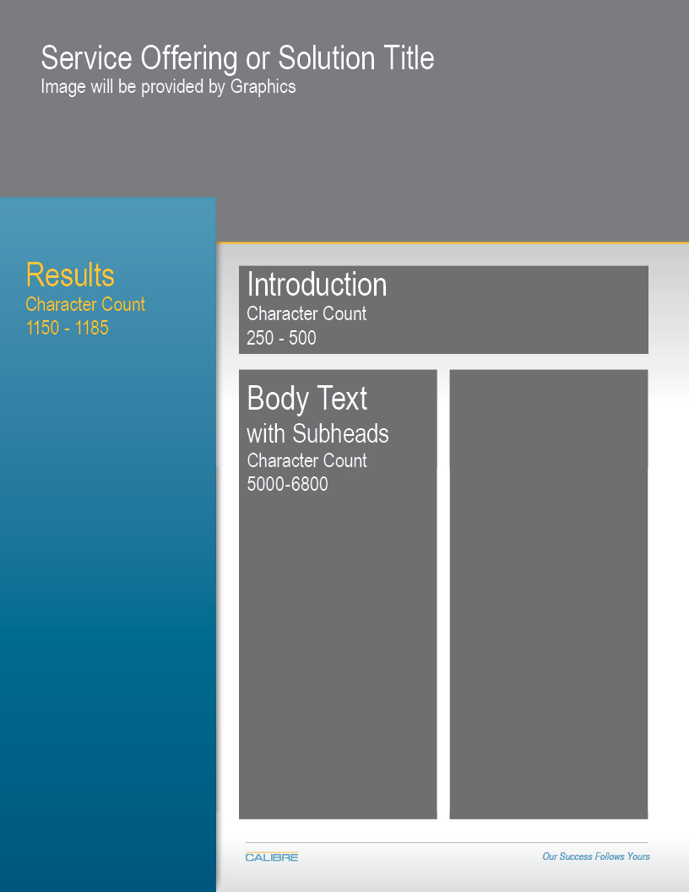

Please note the character counts for each section.

|  |  |  |  |  |  |
| --- | --- | --- | --- | --- | --- |
| POC Information: | | Evan Lynch | | evan.lynch@calibresys.com |  |
|  | | | | |  |
| Service Offering orSolution Title | |  | | |  |
| Overview: Staff-to-Door Allocation (SDA) Tool | | | | |  |
|  | | | | |  |
| Key Benefits 1150 - 1185 characters | | | | |  |
|  | | | | | |
|  | 1. **Confident Decision-Making** | Move away from decisions that leave you second-guessing. You can be confident that each decision is driven by data, and takes into account the bigger picture. | | | |
|  | 1. **Increased Productivity** | Enable your team to be more productive. SDA considers management targets when assigning workload, assigning each team member with a set of doors that will enable them to meet or exceed the target. | | | |
|  | 1. **Distributed Workload** | Ensure that workload is distributed as evenly as possible. When assigning workload to someone, SDA’s decision model takes into account the amount of work assigned to everyone else, which prevents the overloading any one person. | | | |
|  | 1. **Realistic Targets** | Every once in a while the total workload in the building may fall below management targets, making these targets unachievable. In these situation, SDA can readjust targets to match available workload. This allows managers and the teams they lead to be more realistic about what is achievable. | | | |
| Intro 250 – 300 characters | |  | | |  |
| Do inbound or outbound managers at your distribution center struggle to assign their people the right amount of workload throughout the day? Does every day feel like a firefight, due to the high volatility in carton volume? | | | | |  |
| Intro II 250 – 300 characters  Top performing distribution networks have gained a competitive edge, in large part because of their ability to harness their data to make optimal decisions. SDA is a new CALIBRE solution that can empower operational-level managers to make better and faster decisions by leveraging data with a powerful, yet simple software solution. SDA is designed to make the job of an operations manager easier, while simultaneously enabling the utilization of staff to be optimized throughout the day. | | | | |  |
| Body Text with subheadings 5800 – 6800 characters | | |  | |  |
| >>SDA fits seamlessly into the current resource allocation process for inbound/outbound operations:   * (Insert graphic 1 from PowerPoint slide)   *Page 2*  CALIBRE is committed to ensuring the successful rollout of SDA at your facility, and we understand the challenges that can come with integrating a new solution into your process. To help with that, we’ve developed a general implementation framework that keeps your success in mind throughout every step of the process.   * (insert graphic 2 from PowerPoint slide)   >>SDA is most valuable for facilities that generally meet the following criteria:   1. Need for Improvement: There is a need to significantly improve the allocation of scarce resources, because the current approach is not yielding expected results.    * For some facilities this may mean that productivity metrics are suffering, stagnant, or inconsistent.    * Other facilities may be short-staffed, and current employees may be experiencing a constant tug-of-war for their time. 2. Decision Complexity: Managers need to make complex resource allocation decisions very quickly with several, sometimes thousands, of available options. Factors that affect the complexity of the decision process include:    * Size of the workforce    * Size of the facility    * Volume processed by the facility in a typical day    * Level of volatility in volume throughout the facility over time 3. Data Quality: The number of cartons that will be routed to a door is either known before resource allocation decisions need to be made, or can at least be modeled/predicted accurately. If neither is possible, SDA can still be used as a benchmarking tool, comparing actual performance to a more realistic ideal state. | | | | |  |
|  | | | | |  |

Other changes:

* Add * to the bottom of first graphic: *\*SDA can also be run once per day, or at any time interval that makes sense for the facility*
* Change “Model Output” on first graphic to “SDA Output”
* Do you have any suggestions to improve this?
* Did we create those icons internally?
* Discuss palletized loading vs manual
* Un-bold second intro
* Need to figure out a way to make the final section on the second page look nicer. Does it need to be 3 columns?